(approx. 1660 words)

Backing up a computer - Cloning VS Imaging
By Al Edmister, a member of the Napa Valley PCUG, California
www.nvpcug.org
AeinNapa(at)aol.com

Obtained from APCUG with the author's permission for publication by APCUG member groups.

Backing up your computer has always been an important and sometimes confusing subject. As most people know by now backing up on the same HD only helps when the main file gets corrupted which really doesn’t happen very often. It is of no help when an HD fails. I’ve had two fail. The first failure was soon after I bought the machine; the HD was defective. The manufacturer replaced it and, luckily, files could be copied. But all programs had to be reinstalled. The second time the HD motor quit. That was hard to find; HD motors are really quiet and who would think to put ones head into the box to listen. Anyway all was lost. Well, not all, because I had started keeping all my files backed up on a second internal HD so I had everything but an OS and programs. I bought a new HD and installed an OS and programs again then copied back my files. Very time consuming. There had to be a better way should failure happen again.

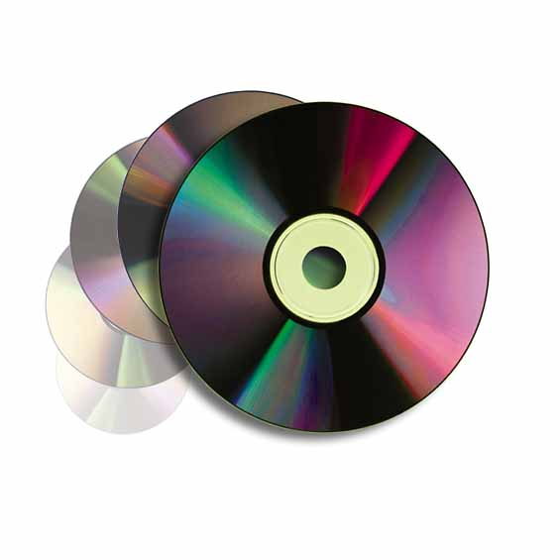
At one time I thought CD-RWs & ‘READ ONLY disks would be the answer. In fact, I’m using this method with another computer which doesn’t get much action or have big files. And it doesn’t have space for a 2nd HD. To clinch it the UBS is a 1 which makes for slow transfers of big files. But, with not many transfers, no music or games, to make, a CD-RW system works fine for us as we only need to up date them occasionally and we keep photos on a remote computer and read only disks anyway.

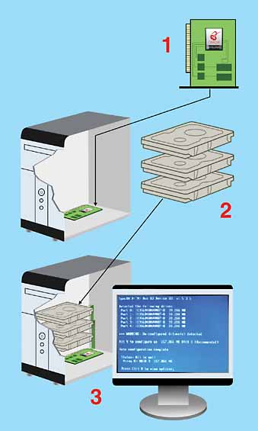
I heard about RAID and found out that it requires a card on the mother board and two (2) or more HDs depending on the array. RAID has multiple HDs all running containing the same every thing; if one drive fails then, without shutting down, you remove & replace it with a clean drive and RAID recreates from the remaining drives. No downtime is the key advantage here. It can get expensive.

There are all kinds of RAID arrays. One of them is with 2 HDs & is called “striping” where info is written alternately to the disks. Makes for much faster read & write & is really helpful when doing videos.

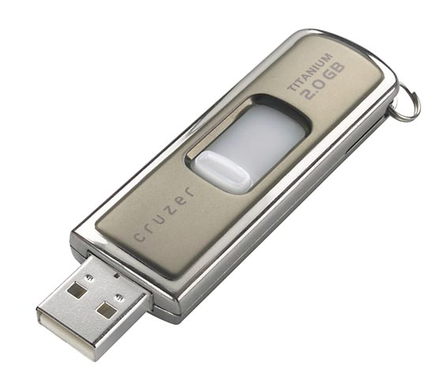
I also heard about Zip drives. Never used them but I think they came into use before there was UB 2 and before large HDs. A Zip drive is removable and contains compressed files. It is handy not only for same computer back up and additional storage but as a system to transfer files from one computer to another. But you can’t get a ‘full’ back up.

That’s when I heard about cloning and imaging. Cloning of an HD vs Imaging it had not been settled, at least not for me, until recently. The following may not be everybody’s take but it works for me. Cloning is making an exact, complete, bootable copy; imaging is making a compressed bootable copy where the files are compressed versions of the original in a dedicated file format. It can then be used to create a working duplicate of the original on a blank HD disk. The clone or image can be externally USB connected or internal. A clone takes up less space on a disk than the original as does an image but more space is need for an image, at least when using True Image ! ver. 10.0 by Acronis (http://www.acronis.com/), because each time you do a back up it is what they call an incremental back up or a ‘slice’ and needs it own space. Programs like True Image can keep you automatically up dated on a scheduled basis or you can do an update when you feel it’s necessary and you have the time. Working on imaged files might be possible but I have no idea how. They are “just there” for use in recreating an HD.

But I wanted a duplicate, bootable HD running as a D drive in case my C drive fails. That is, I want a clone of my HD not an image. I already had and keep via “save as” all my files on my D drive. I mean all! But, I did not have the OS or programs on it. Also, I wanted to switch D & C as disk now in D is bigger and better suited to be in the C position where I can put large temporary files. I have no need of partioning, so neither drive is partitioned.

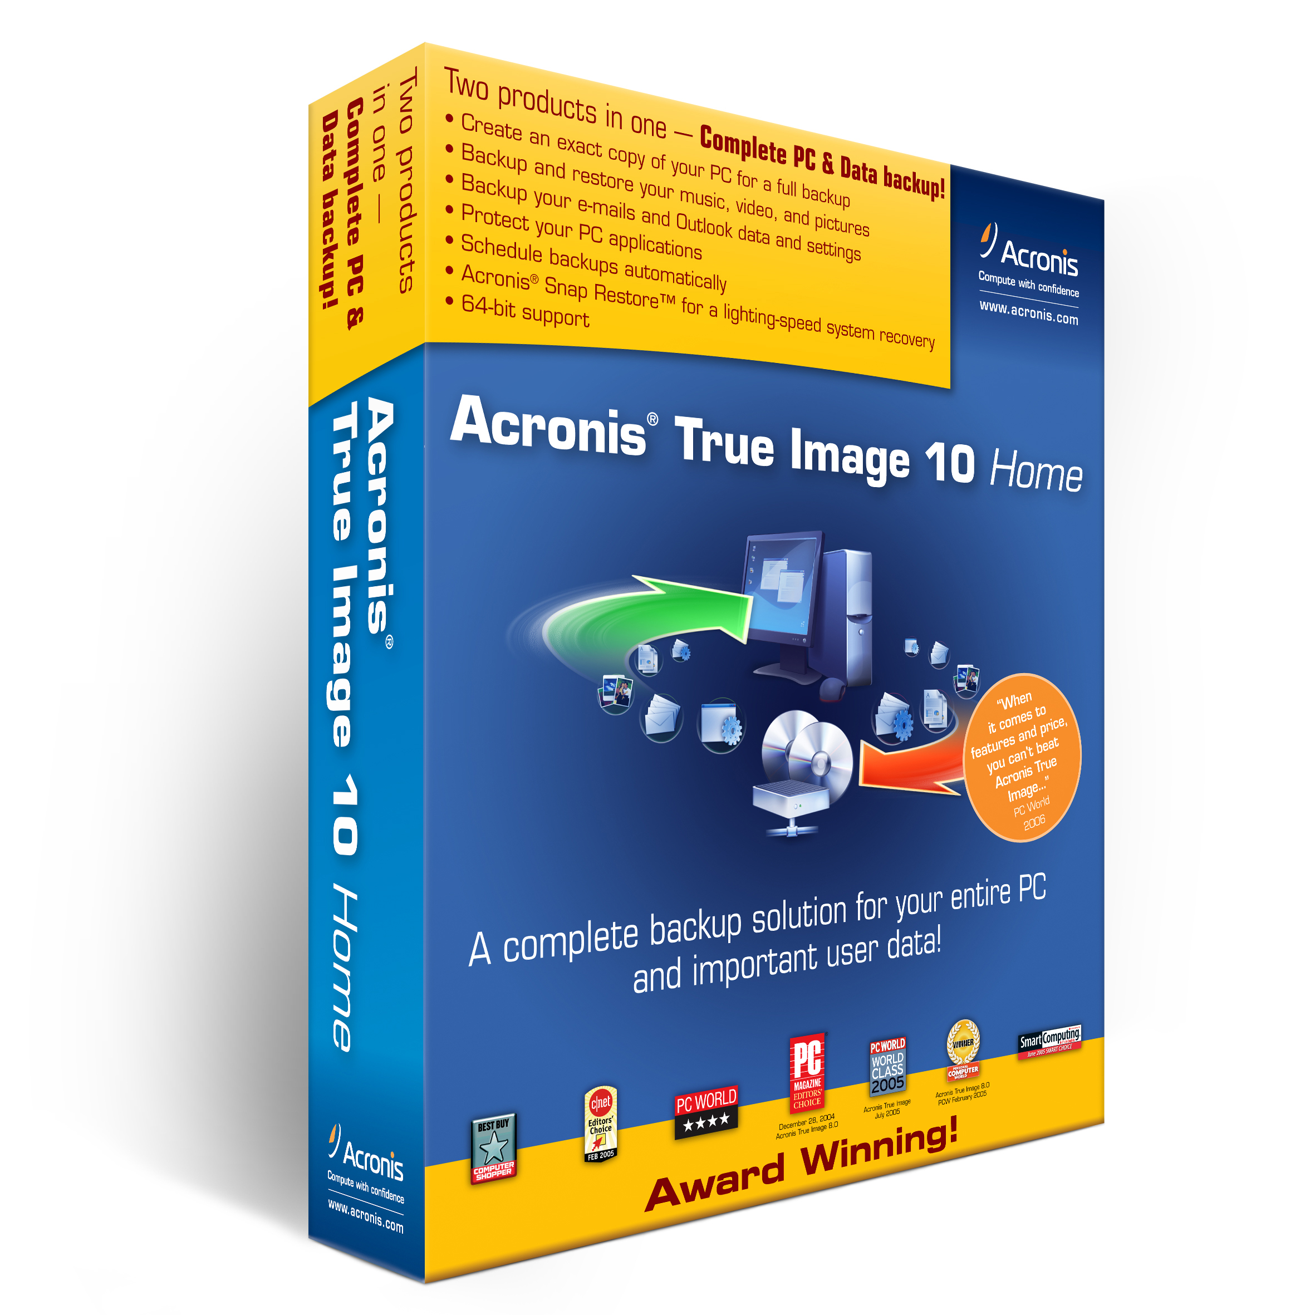
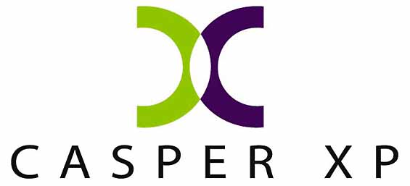
I tried Casper XP by Future Systems Solutions (http://www.fssdev.com/), a really good cloning program. Unfortunately for me, there is a conflict with the way Casper works & something in my computer that prevents it from functioning completely. This very likely is an isolated problem; but still, even with Casper’s built in history & status utilities I, & their tech, could not find it. I was impressed with their tech guy. I got prompt answers and personal help. He even called me the first morning after I had emailed a help request and I have his direct line number. Emailing the self-generated reports was easy and we were able to remove some old W98 fragments. But the conflict remained. We gave up. I gave my copy of Casper to Diane Prior.

I then went to True Image 10.0, which, at first I thought only did imaging. I gave it a try imaging my C drive to an external USB connected H drive. That took seven hours and I have yet to figure out the restore process works because their restore page doesn’t use the terms “source” & destination” but something obscure to me. Anyway I have an image on a removable drive ready if I should need it.

Note: In addition to the three products I used were Casper XP, Maxtor & the one by Acronis, but you can find several additional back up products by doing a GOOGLE search for backup programs. Among the 10,000.000+ entries on the words backup programs, I was reminded that Windows Backup System (part of XP) and Norton Ghost are both backup program available.

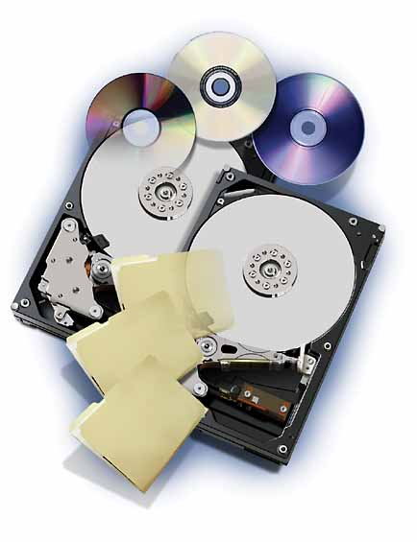
For the next part, I wanted a cloned back up running as a second HD as I intend to keep using “save as” as I go along rather than wait for a scheduled time. My work is important to me and even losing a few minutes of effort is not acceptable. I also wanted a bootable 2nd HD fully backed up (OS, all programs, settings as well as files) in case my C drive failed. Tucked away in True Image 10.0 is a button to go to clone, any disk to any disk. True Image 10.0 did the job and in less than an hour I had moved over 30 GB of OS, programs and files to a bootable drive.

I opened up my computer case; switched C & D and turned on the power. The cloned drive (old D) came up as if it were always there as a C drive. Everything was exactly as I had left it even the partially filled Recycle Bin. Great, now for checking out the drive in D, which now held my old C drive. No drive could be found. It just wasn’t there. I opened the computer & checked the connections & pining; they were fine. I then went to www.techguy.com with the problem. Back came a reply to go to disk manager and send a screen shot. While there I saw that the drive had not been assigned a letter. Which I thought XP did automatically. I entered the letter D and went back to see what had happened. I was in business. All drives function as intended. I was as happy as a mosquito in a blood bank.

The future might be in flash drives already available as thumb or flash gizmos. They are getting bigger, over 2GB ones are available, and are great for transferring files. Hang one around your neck on a lanyard or just stick one in your pocket, these drives are smaller than a disposable cigarette lighter, so they travel well. No moving parts is a huge advantage as there’s no mechanism to fail. Internal HDs might eventually be made similar to flash type drives. But before this can happen, they will have to be over 200GB to take the market.

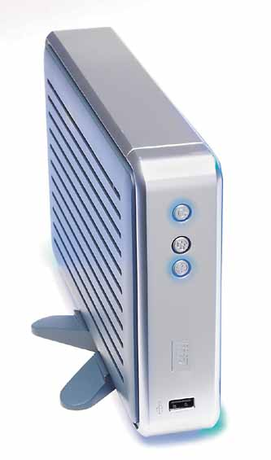
There is a new wrinkle to cloning an HD that I just discovered and used. My ‘new’ computer, while a definite upgrade in speed, has space for only one HD which was an 80GB. That is actually big enough for my purposes but I wanted a second bootable HD for back up even though I’ll have to run it as an external drive in a USB port. Therefore, recently I bought a 160GB Maxtor drive.

It came with the usual installation disk, but it included a feature I wasn’t aware of until opening it. I put the drive into my external drive holder, plugged everything in and began with the configuration, then the disk copy. Forty minutes later, I had a cloned disk which I then put in my computer pinned as master and I am up and running again. This time it is on a 160GB (120GB available) and I have the old 80GB HD as a bootable HD in the external case as back up.

Note: Additional programs for backup, security, the Internet and disk organization can be purchased by user group members from (http://www.ugr.com/).

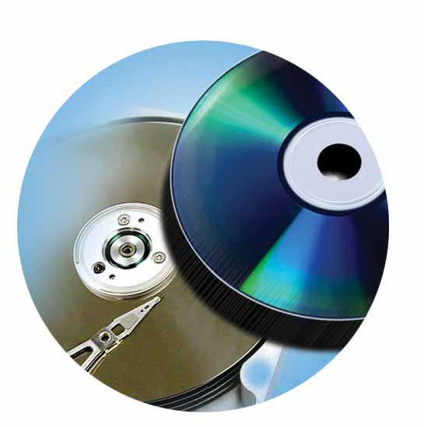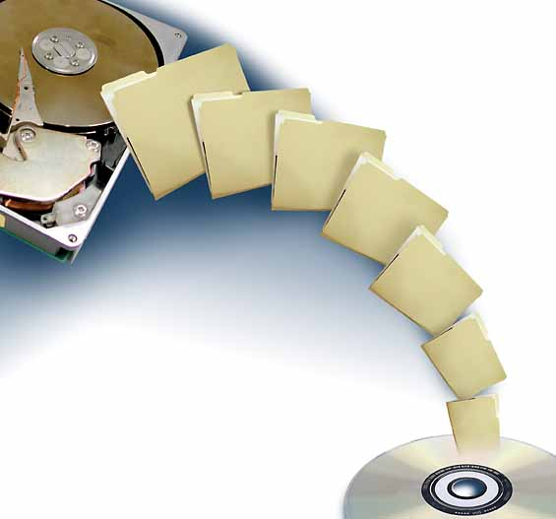

This article has been provided to APCUG by the author solely for publication by APCUG member groups. All other uses require the permission of the author (see e-mail address above).

